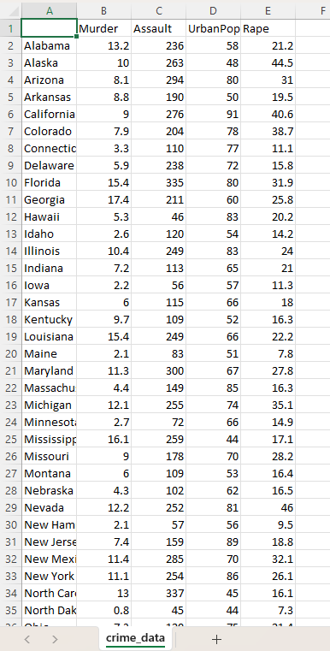

Name of Feature Description Type Relevance w.r.t other Features
1.Murder Murder arrests Quantitative, Continuous Murder arrests per country people
2.Assault Physical Attack Quantitative, Discrete Arrests for physically attacking someone
3.Urban Pop Urban Area Population Quantitative, Discrete percentage of states population living in
urban area
4.Rape Sexual act Quantitative, Continuous Arrests for sexual-act per country people

